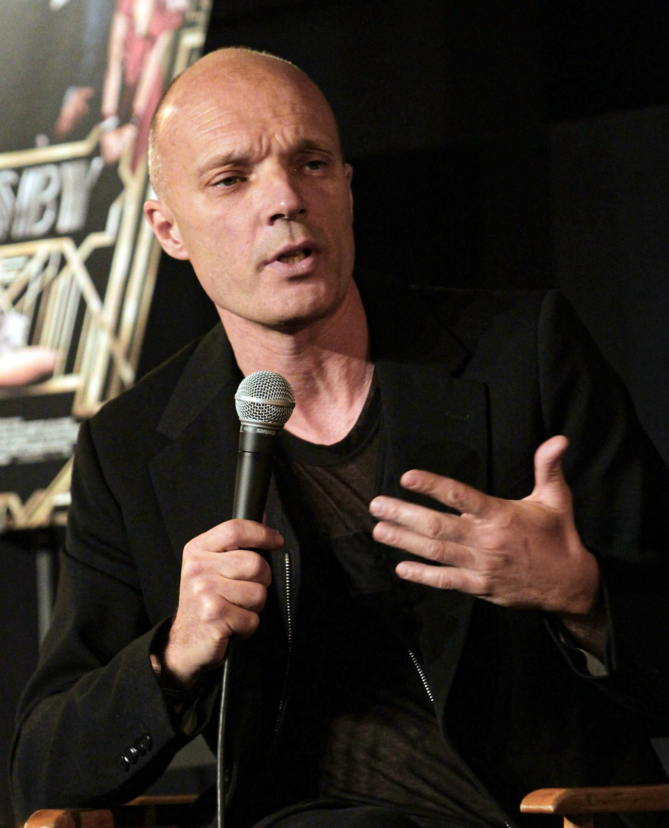
Production Designer ANDY NICHOLSON is best known for his work with Director Alfonso Cuarón on 'Gravity,' which earned him OSCAR and BAFTA nominations for Production Design and an Art Directors Guild award for a fantasy/sci-fi film.

Andy recently completed work on ‘Ibelin’ for Director Morten Tyldum.

His other feature film credits include the upcoming 'Voltron' for Writer-Director Rawson Marshall Thurber 'The School for Good & Evil' for Director Paul Feig, 'Red Notice’, also for Rawson Marshall Thurber, ‘Captain Marvel' for Directors Anna Bowden and Ryan Fleck, and 'Jurassic World: Fallen Kingdom' for Director J A Bayona. He also served as Production Designer on 'Assassin's Creed' for Director Justin Kurzel, the science fiction action-drama 'Divergent' for Neil Burger, and the sci-fi thriller 'The Host' for Andrew Niccol.

In Television, Andy recently Designed the series 'ALIEN: EARTH' for Showrunner Noah Hawley and 'Constellation' for Showrunner Michelle MacLaren.

Nicholson has worked multiple times with Director Tim Burton, beginning in 1999 as an Art Director on 'Sleepy Hollow,' which earned him an Art Directors Guild (ADG) Award. He was also nominated for an ADG Award for his work on Burton's 'Charlie and the Chocolate Factory.' Subsequent collaborations include roles as Supervising Art Director on 'Alice in Wonderland' and as a visual development Art Director for 'Frankenweenie.' Andy received another ADG Award for 'The Golden Compass' and nominations for 'The Bourne Ultimatum' and 'Captain America.' His Supervising Art Director credits extend to 'The Wolfman,' 'RocknRolla,' 'The Holiday,' and 'Breaking and Entering.' Additional Art Direction credits include 'Spy Game,' 'Troy,' and 'The Good Thief'

